Bank Transactions Analysis Using Python, SQL, and Power BI

1. Introduction
The banking industry generates a massive volume of transactional data every day through various channels such as online banking, ATMs, and branch operations. Analyzing this data is essential for understanding customer behavior, monitoring transaction patterns, improving operational efficiency, and supporting business decision-making. Data analysis in banking helps organizations identify trends, detect unusual activities, and provide better customer services through data-driven insights.
This project focuses on the analysis of banking transaction data using Python, MySQL, and Power BI. The dataset contains information related to customer demographics, transaction amounts, transaction types, account balances, login attempts, transaction duration, and banking channels. The project follows a complete data analytics workflow beginning with data cleaning and preprocessing, followed by exploratory data analysis (EDA), SQL-based business analysis, and interactive dashboard creation.
Python libraries such as Pandas, Matplotlib, and Seaborn were used for data preprocessing and visualization. MySQL was used to perform analytical business queries and extract meaningful information from the dataset. Power BI was used to create an interactive dashboard for visual representation of key insights and trends.
The main objective of this project is to analyze customer transaction behavior, identify important financial patterns, compare transaction activities across different banking channels, and generate actionable insights through visual and statistical analysis.

2. Objectives of the Project
The primary objectives of this project are:
- To perform data cleaning and preprocessing on banking transaction data.
- To analyze customer transaction behaviour using exploratory data analysis.
- To identify trends and patterns in transaction activities.
- To perform SQL-based business analysis using MySQL.
- To build an interactive Power BI dashboard for data visualization.
- To generate meaningful business insights from the banking dataset.
- To understand customer segmentation based on age, occupation, and account balance.
- To identify potential anomalies and unusual transaction behavior.

3. Dataset Description
The dataset used in this project contains banking transaction records and customer-related information. The dataset includes both numerical and categorical variables that help analyze customer behavior and transaction patterns.
Rows = 2512
Columns = 16
Important Columns Used
Column Name | Description
transactionid | Unique ID for each transaction
customerid | Unique customer identifier
customerage | Age of customer
transactionamount | Amount involved in transaction
transactiontype | Type of transaction (Debit/Credit)
transactionduration | Time taken to complete transaction
channel | Transaction channel (ATM/Online/Branch)
accountbalance | Customer account balance
loginattempts | Number of login attempts
customeroccupation | Occupation of customer
transactiondate | Date of transaction
location | Transaction location
The dataset was cleaned and transformed before analysis to ensure consistency and improve analytical quality.

4. Tools and Technologies Used
1. Python – for data cleaning and analysis.
2. Pandas – for data manipulation
3. Google Colab/Jupyter Notebook – for development environment
4. Seaborn – for statistical analysis and visualization
5. MySQL – for query analysis and business insights.
6. PowerBI – Interactive dashboard creation.

5. Data Cleaning and Preprocessing
Data preprocessing is one of the most important stages in the analytics workflow. The dataset was cleaned and prepared before performing analysis.
Steps Performed
5.1 Loading Dataset
The dataset was imported into Python using Pandas.
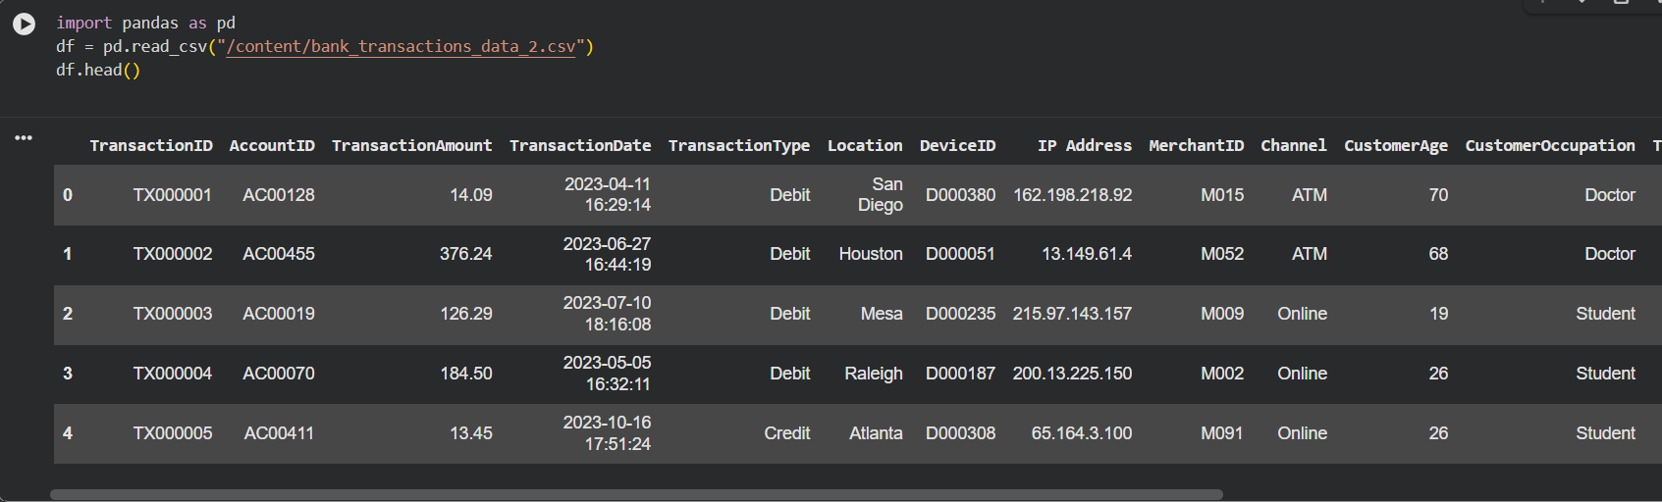
5.2 Dataset Inspection
Basic inspection was performed using:
print(df.info())
print(df.describe())
This helped understand:
- data types
- missing values
- statistical summary
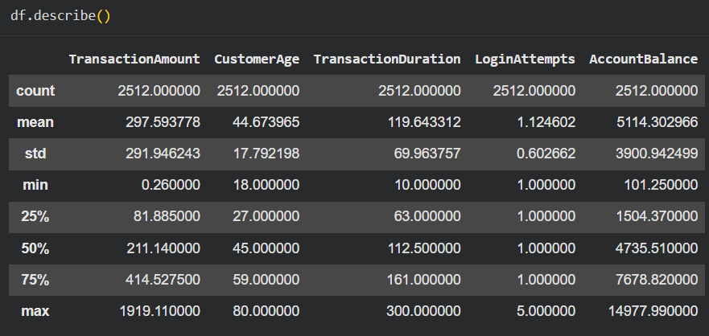
5.3 Missing Value Analysis
Null values were identified and handled appropriately.
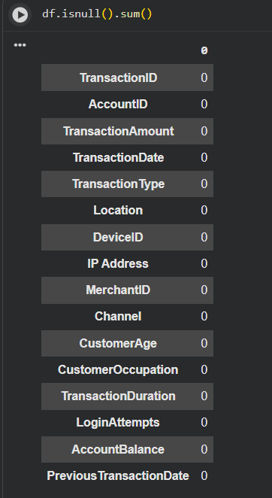
5.4. Column Standarization
Column were renamed to lowercase for better readability and documentation.
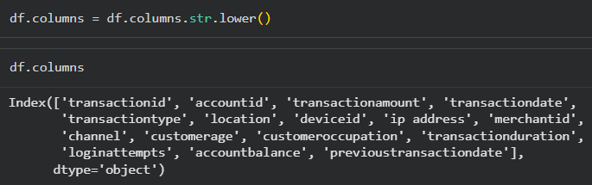
5.5 Feature Engineering
- created age_group column by binning customerage for better segmentation.
- created high_valuetransactions column for analysing customer transaction behaviour with higher transaction amounts.
5.6 Date Formatting
Transaction date column was converted into datetime format.
df['transactiondate'] = pd.to_datetime(df['transactiondate'])
Additional time-related columns were extracted for trend analysis.
6. Exploratory Data Analysis (EDA)
Exploratory Data Analysis was performed to understand the dataset, identify patterns, and generate meaningful business insights.

6.1 Transaction Amount Analysis
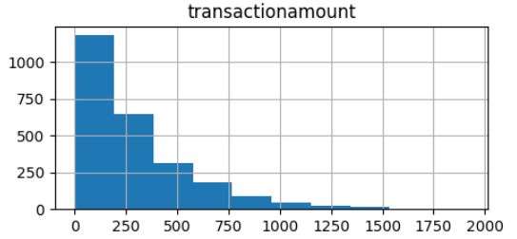
Observations
- Transaction amounts were highly right-skewed.
- Most transactions involved smaller amounts.
- Few transactions had very large values.
Business Insight
This indicates that customers usually perform routine low-to-medium value transactions, while high-value transactions occur less frequently.
Outlier Analysis
The transaction amount column contained several large outliers. Since large transactions are realistic in banking systems, these observations were retained for further analysis instead of being removed directly.

6.2 Customer Age Analysis
Customer age distribution was analyzed using histograms.
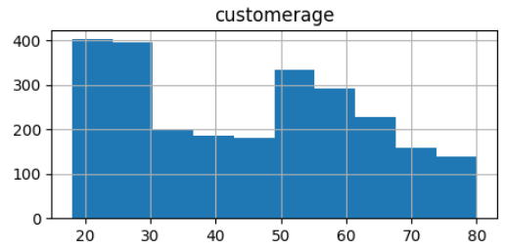

Observations
- Customers belonged to multiple age categories.
- Significant concentration was observed in adult and middle-aged groups.
- The bank serves a diverse customer base.
Business Insight
Different age groups may exhibit different spending patterns, transaction preferences, and banking behavior.

6.3 Transaction Duration Analysis
Transaction duration was analyzed to understand operational efficiency.
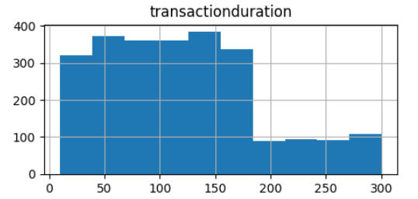
Observations
- Most transactions were completed within moderate durations.
- Very long transaction durations were relatively rare.
Business Insight
Long-duration transactions may indicate network delays, processing issues, or complex banking operations.
6.4 Login Attempts Analysis
Login attempt distribution was analyzed.
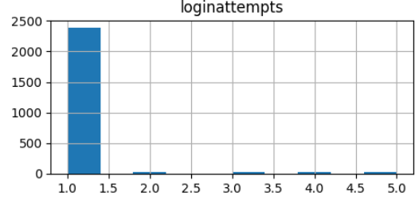
Observations
- Most customers successfully logged in on the first attempt.
- Higher login attempts were relatively rare.
Business Insight
Repeated login attempts may indicate authentication problems or suspicious behavior.
6.5 Account Balance Analysis
Account balance distributions were analyzed.
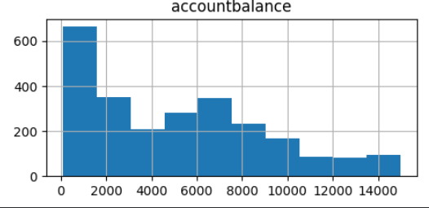
Observations
- Account balances were positively skewed.
- Most customers maintained moderate balances.
- A smaller group of customers maintained significantly higher balances.
Business Insight
This reflects realistic banking behavior where a smaller group of customers contributes higher account value.

6.6 Transaction Type Analysis
Debit and credit transaction distributions were analyzed.
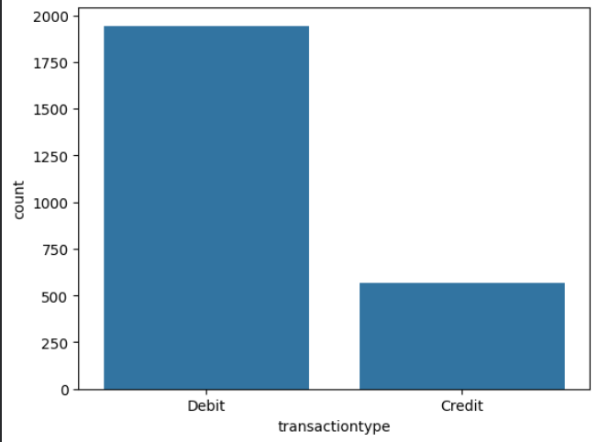
Observations
- Debit transactions were significantly higher than credit transactions.
- Debit operations dominated overall customer activity.
Business Insight
Customers primarily use banking services for payments, purchases, and outgoing transactions rather than incoming credits.

6.7 Channel Analysis
Transaction activity across ATM, Branch, and Online channels was analyzed.
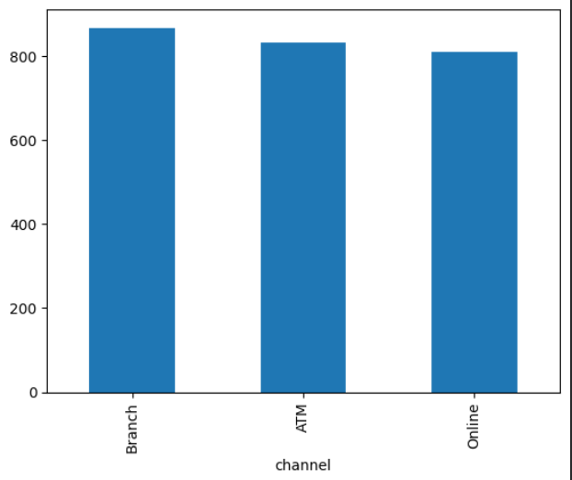
Observations
- Transaction activity was relatively balanced across all channels.
- Branch transactions were slightly higher.
Business Insight
Customers actively use both physical and digital banking services, indicating multi-channel engagement.

6.9 Outlier Detection
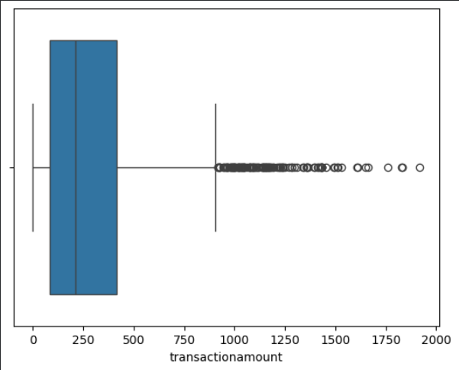
Observations
- Box shows majority customers transactions, dots beyond upper whisker shows these transactions are high compared to normal customer behaviour.
- Possible reasons could be premium customers, bulk transfers, abnormal activities, etc.
- Median line in box is closer to left side, this indicates majority of transactions are smaller amounts.

6.10 Heatmap analysis:
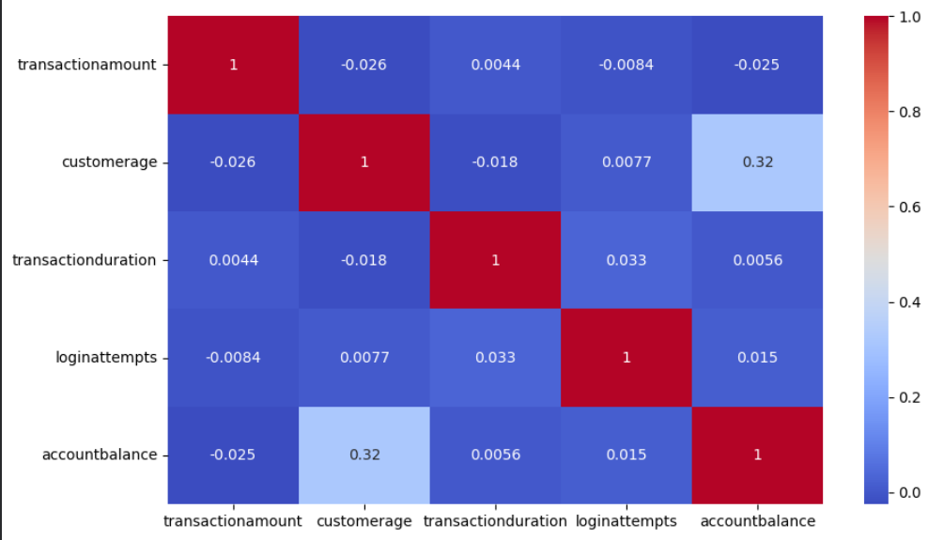
Findings:
1. Customer age and account balance (r = 0.32)
- customerage and accountbalance has positive relation (r = 0.32)
- older customers tend to maintain slightly higher account balances.
- This suggests age may influence financial capacity.
2. Transaction amount vs customer age (r = -0.026)
- very weak negative relationship, this indicates transaction amount is almost independent of customer age.
- Insight: Customer across different age groups perform transactions of varying amounts without a strong age-based pattern.
3. Transaction amount vs account balance (r = -0.025)
- almost no relationship exists. This means customers with higher balances do not necessarily perform larger transactions.
- Insight: Transaction size alone may not indicate customer wealth or account value.

7. SQL Analysis Using MySQL
The cleaned dataset was exported from Python and imported into MySQL for analytical querying.
Example SQL Queries and Business Analysis

Query 1: Channel-wise Transaction Value
Business Question
Which transaction channels generate the highest transaction value?
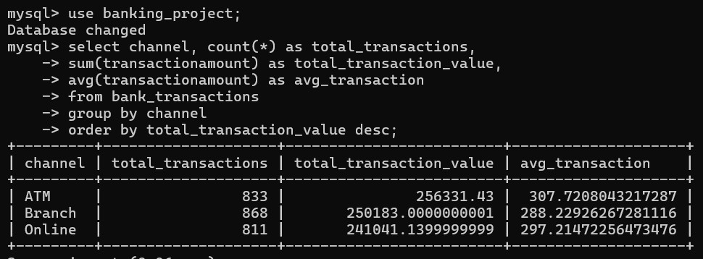
Insight
Branch and ATM channels contributed high overall total transaction value, indicating strong usage across multiple banking channels.
Average transaction is slightly higher in ATMs among all channels.

Query 2: Age Group Transaction Analysis
Business Question
Which age groups contribute the highest average transaction value?
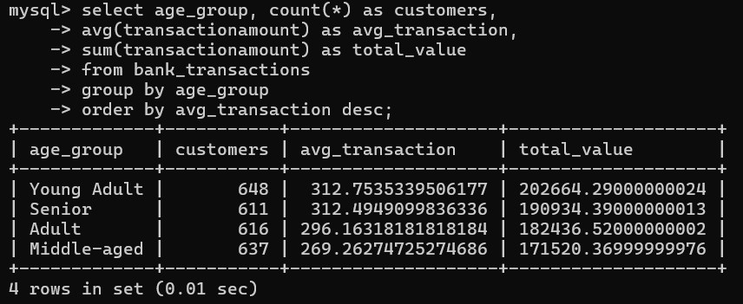
Insight
Young Adult and Senior customer groups contributed higher average transaction values.
Query 3: High Activity Customers
Business Question
Which customers performed the highest number of transactions?
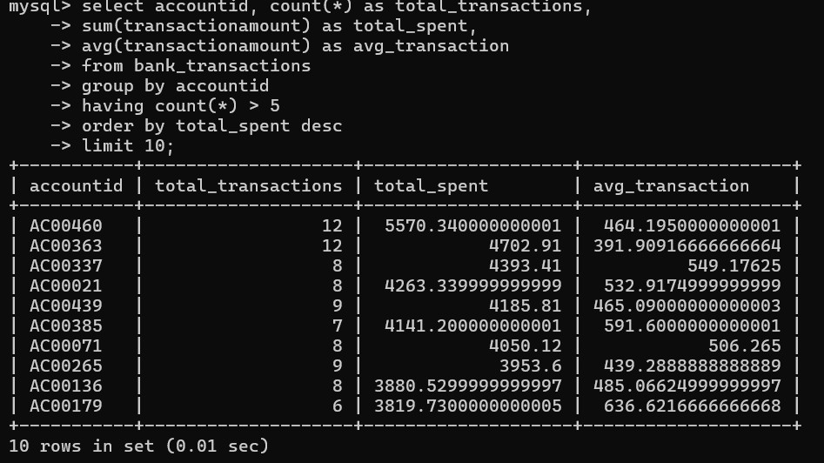
Insight
A small group of customers contributed significantly higher transaction value compared to others. Accounts – AC00460 and AC00363 has highest number of transactions comparatively.

Query 4: Occupation-wise Average Account Balance
Business Question
Which occupations maintain the highest account balances?
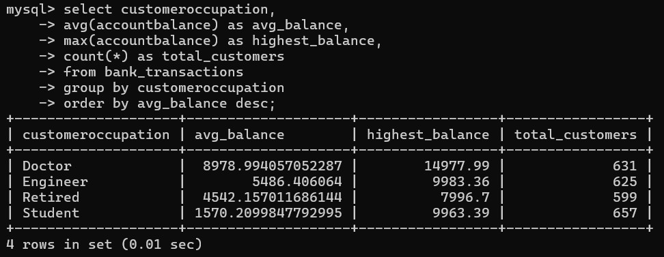
Insight
Doctors maintained higher account balances, indicating stronger financial capacity.
Query 5: Risk-Based Login Attempt Analysis
Business Question
Which transactions involved unusually high login attempts?
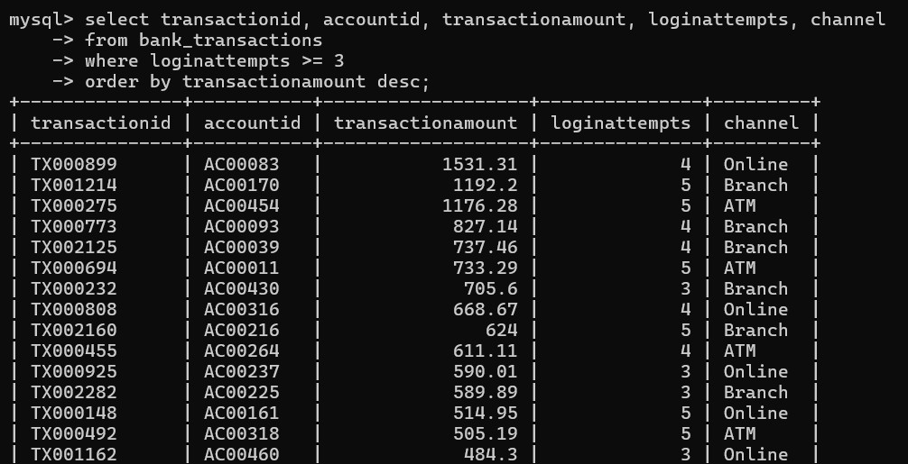
Insight
Transactions involving multiple login attempts may require further monitoring for potential security concerns.

Query 6: Ranking by account balance for demographic analysis
Business Question:
Which customers within each age group had highest account balance?
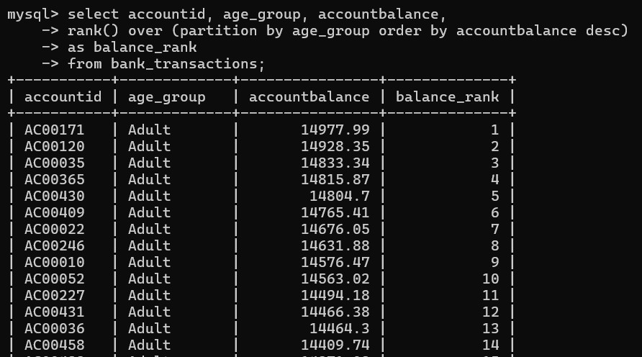
Insights:
Rank-wise segmentation will be useful for loan advertisements, marketing etc.
Query 7: Debit vs Credit transaction behaviour
Business Question:
How debit/credit affected transaction patterns:
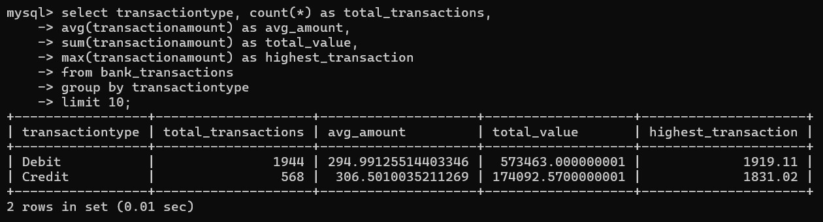
Insights:
Debit transactions are significantly higher than credit transactions. This indicates customers behaviour for out-going transactions rather than incoming credits.

Query 8: Premium or abnormal/suspicious transactions analysis
Business Question:
How many customers are there whose transaction amount exceeds overall average?
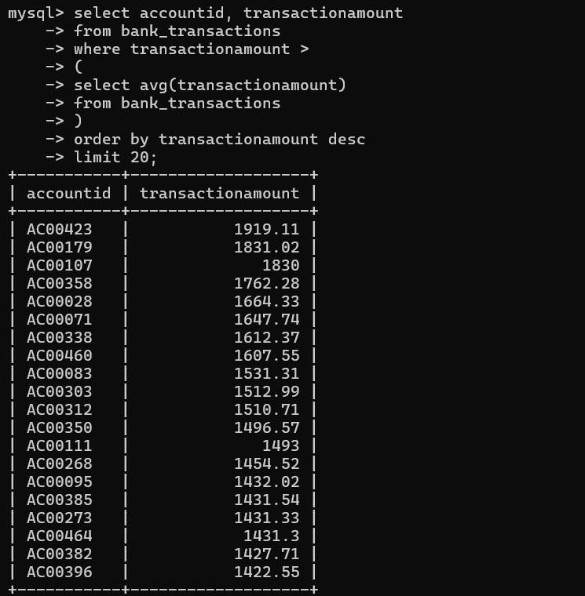
Insights:
These accounts can be analyzed further for any suspicious activity or as premium customers.
Query 9: Transaction duration analysis by channels
Business Question:
Which channels are associated with the longest transaction durations.
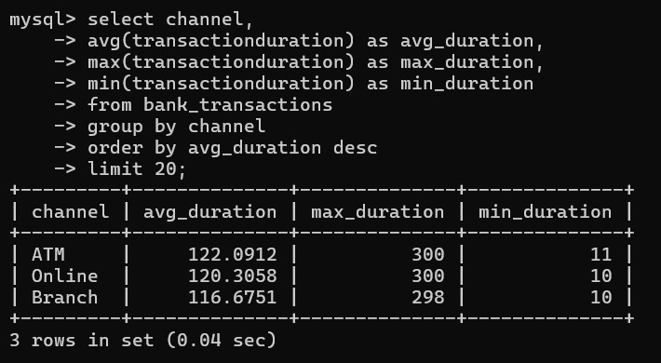
Insights:
ATM and Online channels have longest transaction durations indicating lower system operational efficiency.

Query 10: Customer segmentation by account balance
Business Question:
Segmentation of customers on basis of account balance for targeted marketing/plans.
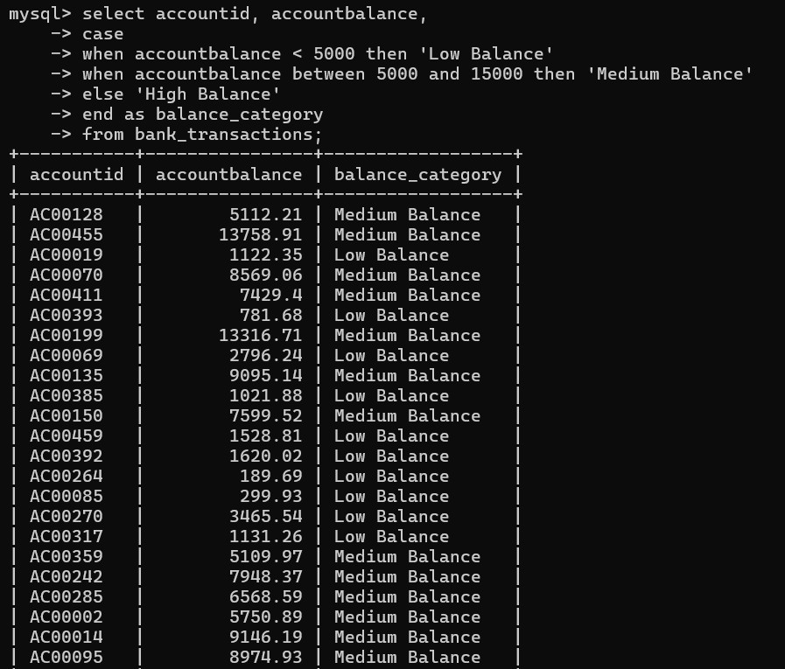
Insights:
Segmented customers on basis of account balance can be analysed further for targeted loan ads and marketing plans.
Query 11: Top 5 customers with highest transaction value
Business Question:
Identifying top 5 customers with highest total transaction value
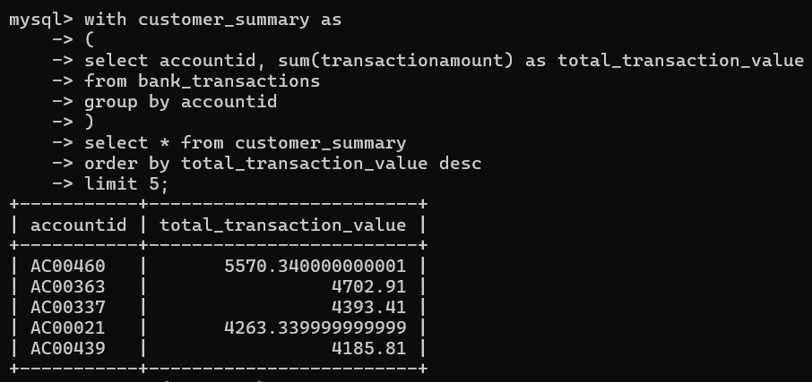
Insights:
Top-most total transaction value customers can be focused on more for customer retention and premium services.

8. Power BI Dashboard
An interactive dashboard was created using Power BI to visualize important business metrics and trends.
Dashboard Components
KPI Cards
- Number of customers
- Average transaction amount
- Average customer age
Visualizations Included
- Monthly transaction trend analysis
- Channel-wise transaction analysis
- Transaction type distribution
- Occupation-wise account balance analysis
- Age group account balance comparison
- Login attempt filtering
- Transaction duration filtering
Interactive Features
- Slicers for login attempts
- Day-wise filtering
- Location filtering
- Transaction duration filtering
Dashboard using PowerBI:
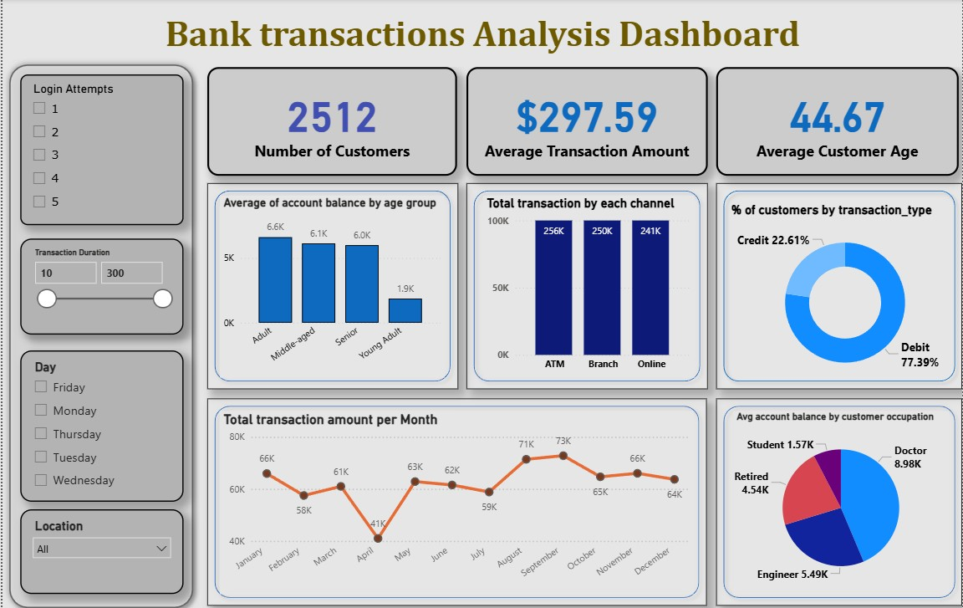
9. Key Findings/ Business Insights:
The major findings from the analysis are:
- Debit transactions dominated customer activity, indicating that customers used bank facilities for out-going transactions more rather than incoming money.
- Transaction amounts were highly positively skewed. Most of the customers did transactions for low-to-medium amounts and few customers did significantly higher transactions.
- Most customers completed login in a single attempt indicating good operational efficiency.
- Branch, ATM, and online channels all showed significant usage indicating multi-channel engagement by customers.
- Adult and middle-aged customers contributed higher financial activity and account balance.
- A small number of customers maintained significantly high account balances, especially from doctor professionals.
- Monthly transaction values fluctuated throughout the year. Total transaction amount dropped significantly from March-April and rise again from April-May indicating customer financial behaviour.
- Highest total transaction amount recorded is in September Month, of total ~$73,000.
- Several high-value transaction outliers were identified and accountIDs are marked.

10. Challenges Faced
Several challenges were encountered during the project:
- Handling missing values and preprocessing the dataset.
- Understanding appropriate visualizations for different business questions.
- Managing skewed financial distributions.
- Integrating Python, SQL, and Power BI into a single workflow.
- Performing meaningful business interpretation instead of only plotting charts.
These challenges helped improve practical understanding of the complete analytics pipeline.

11. Conclusion
This project successfully demonstrated an end-to-end banking transaction analysis workflow using Python, MySQL, and Power BI. The project involved data cleaning, preprocessing, exploratory data analysis, SQL-based business analysis, and interactive dashboard development.
The analysis provided insights into customer transaction behavior, banking channel usage, account balance patterns, transaction trends, and potential anomaly indicators. SQL queries helped extract meaningful business information, while the Power BI dashboard enabled interactive visualization of important metrics and trends.
Overall, the project provided practical experience in real-world data analytics processes and demonstrated how data-driven insights can support business understanding and decision-making in the banking sector.

12. Future Scope
This project can be further enhanced in the future using advanced analytics and machine learning techniques.
Possible future improvements include:
- Fraud detection using machine learning models
- Customer segmentation analysis
- Transaction forecasting and trend prediction
- Risk analysis and anomaly detection systems
These enhancements can further improve decision-making and analytical capabilities in banking systems.

